**The Ark Documentation.**

**How to use the subject custom field uploader to insert custom field data.**

Instruction Path a (with perfect data and no validation)

Log in and select our study.

Once we have chosen our study we will see the following (Study) functions, the last of which is Subject Upload. Click that function.

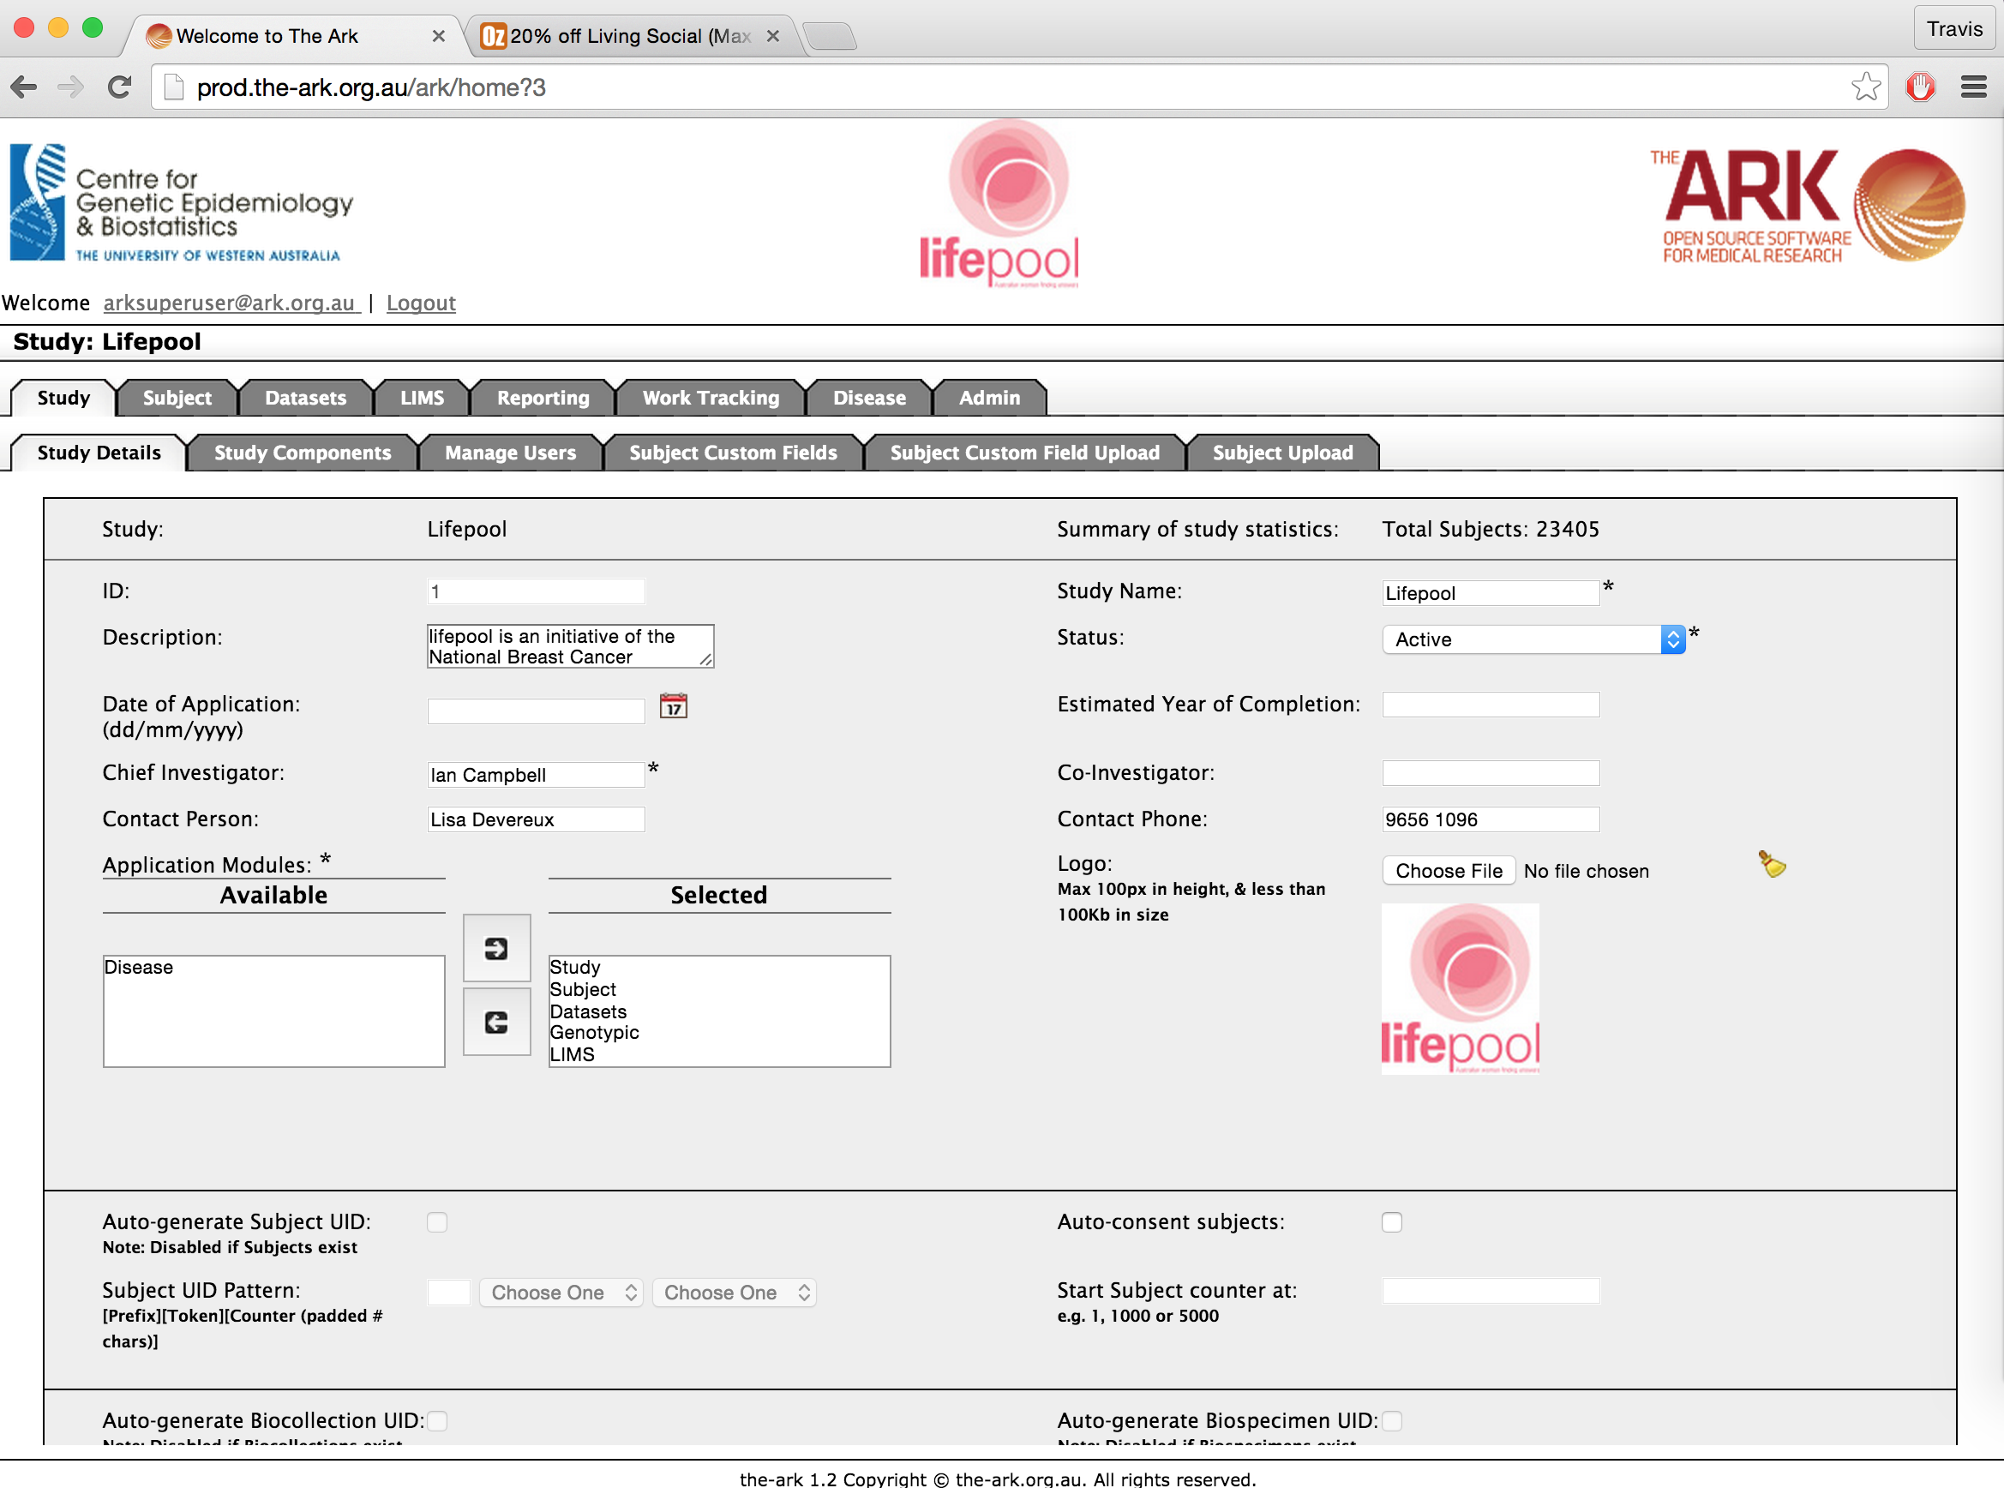

The following page will appear. You will see the following sections from top to bottom;

1. The files upload section. This is where you can begin the steps to upload subjects.
2. The Labels and Template download section. This will be described further below.
3. The Result list section. This section lists all previous uploads.

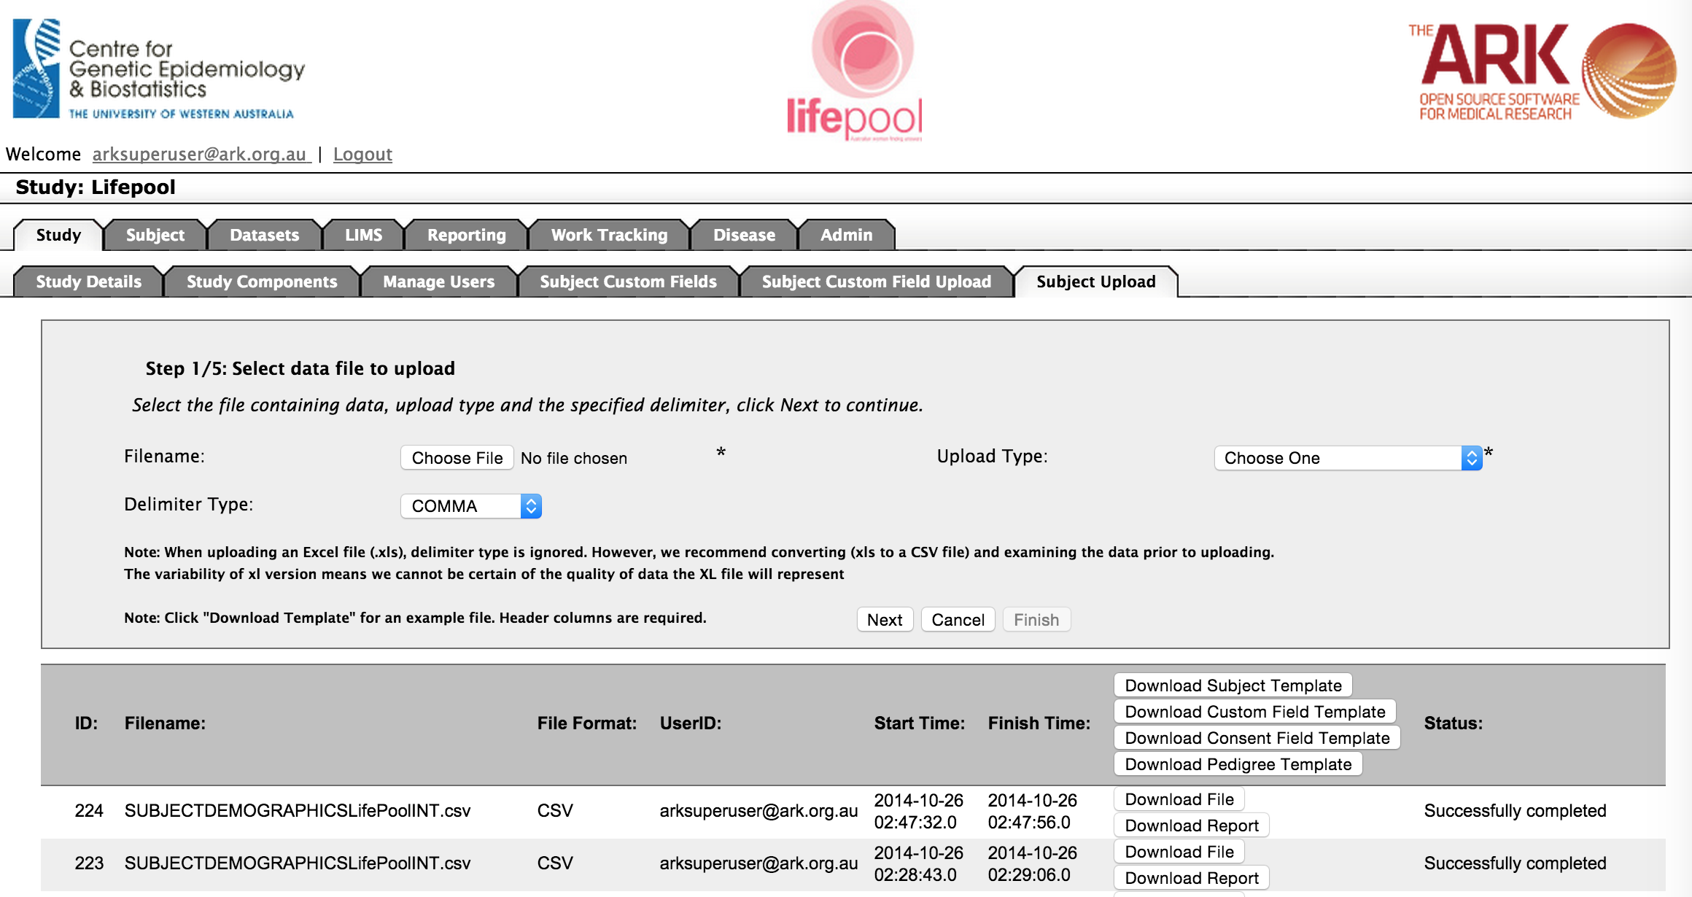

🡨1

🡨2

🡨3

The next step is to upload your data. You have two choices for your starting point;

1. You can select Download Custom Field Template if you are unsure which fields to include. The template lists which fields are mandatory, what type/format of data is expected and valid values for fields that are limited in that way (see below).

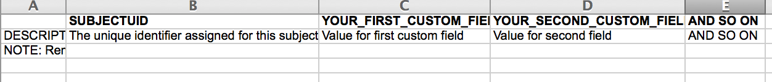

As you can see, this template is more of a guide than a generated file. You have to fill out the field names in the headers eg;



1. Alternatively, you can access an example from the usefulTools/csvTemplatesForUploaders directory of our code repository. If you have not been given a local version of our repository you can access it from

<https://code.google.com/p/ark-informatics/source/browse/#svn%2FARK%2Ftrunk%2FusefulTools%2FcsvDataForUploaders>

For the example below I utilized (Created) the SubjectCustomFieldUploadForWhiteLifePool.csv template file.

Once you have taken the steps listed above to ensure you have the fields you wish to upload, save the file, then you simply;

1. Select the filename of that file in the “The files upload section“.
2. Select the “Study-specific (custom) Data” upload type
3. Leave the delimiter type as CSV (even if using an excel spreadsheet).
4. Click the Next button once.

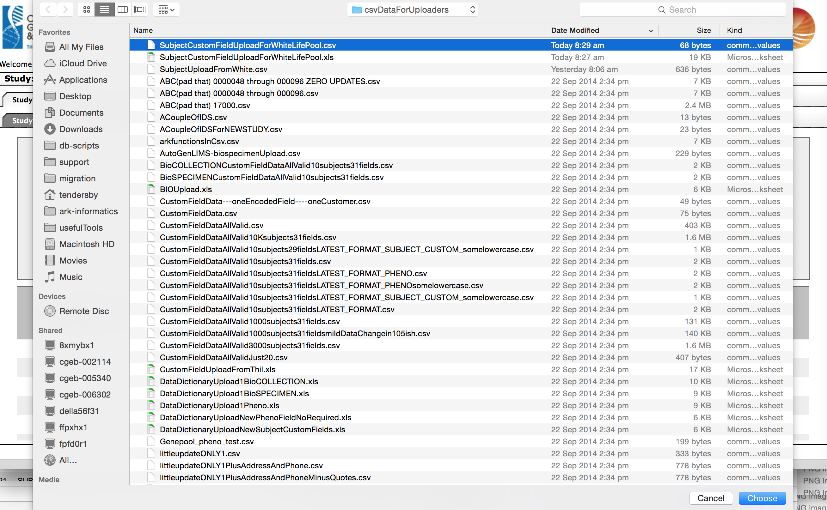

This will take you to the step 2. This page will let you know if the file structure is correct for the upload type. For example, if I had included a field in the headers, which didn’t exist, I would get the following type of error message;

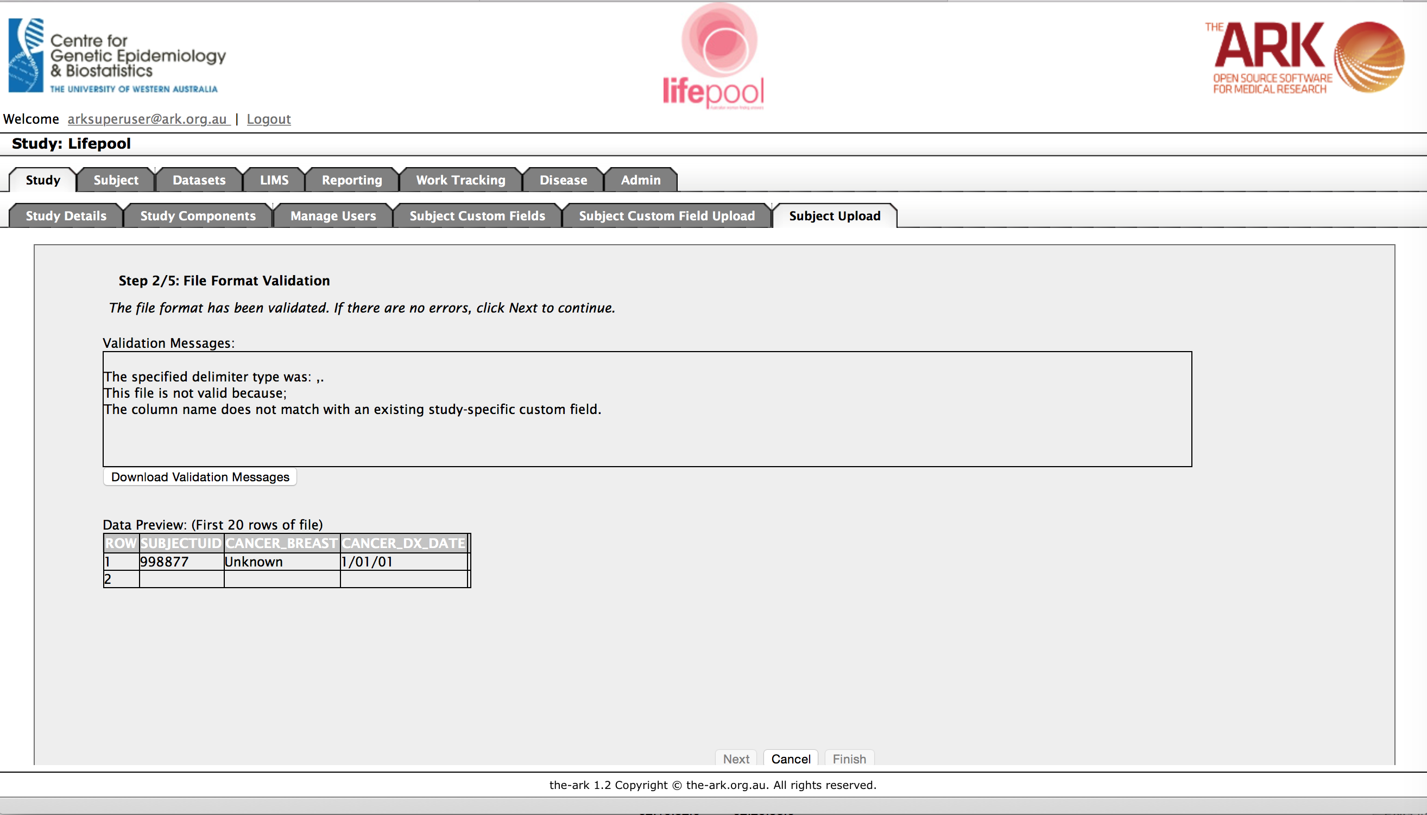

This one turns out to be a rather cryptic issue due to the fact Excel had included an extra comma in its conversion to a CSV file. We can see this by using a normal text editing tool to view the CSV as a text file.

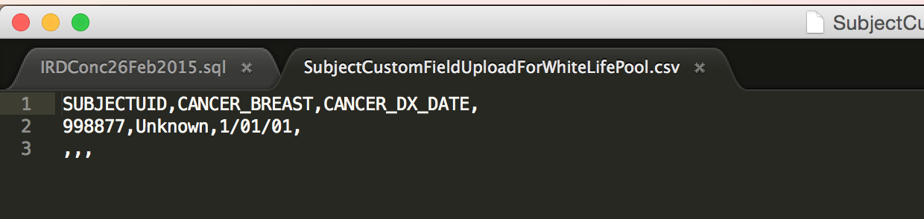

I could manually manipulate the file and remove the excess comma that is on the end of every line, or use a regular expression replacement if I were aware of how to do that. The best approach might be to learn how to make this NOT happen in Excel (see next page).

**Ensuring Excel doesn’t add extra commas and lines;**

Step 1: Select all (or at least those that may have have once had data) columns after our last column of actual data

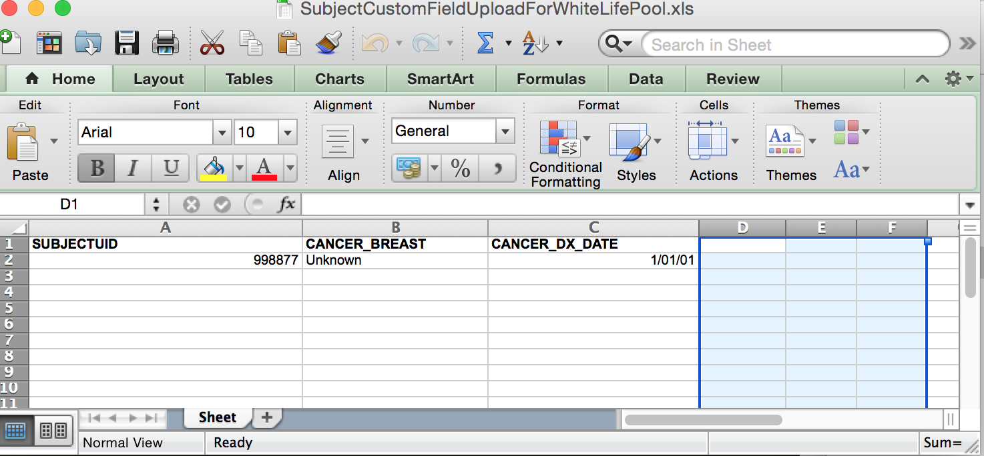

Step 2: Delete selected columns

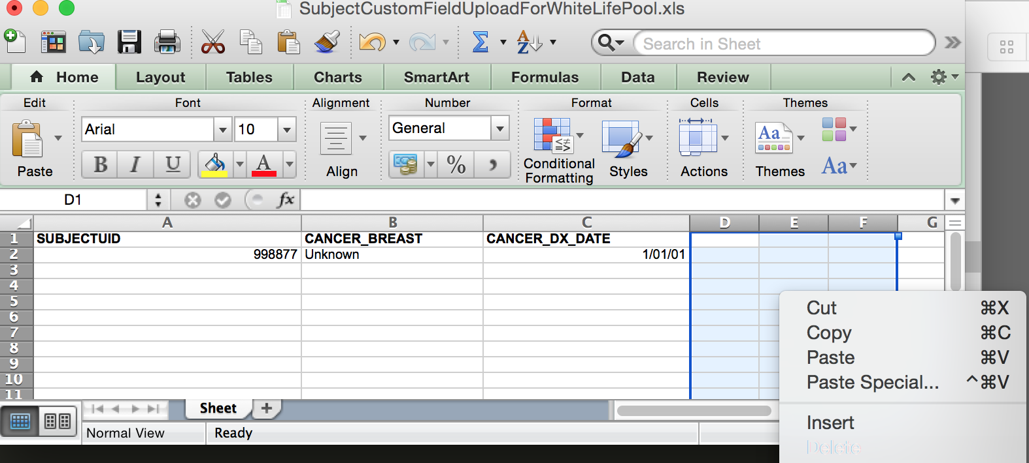

Step 3 & 4; Repeat the process by selecting and deleting all rows after our last row of data.

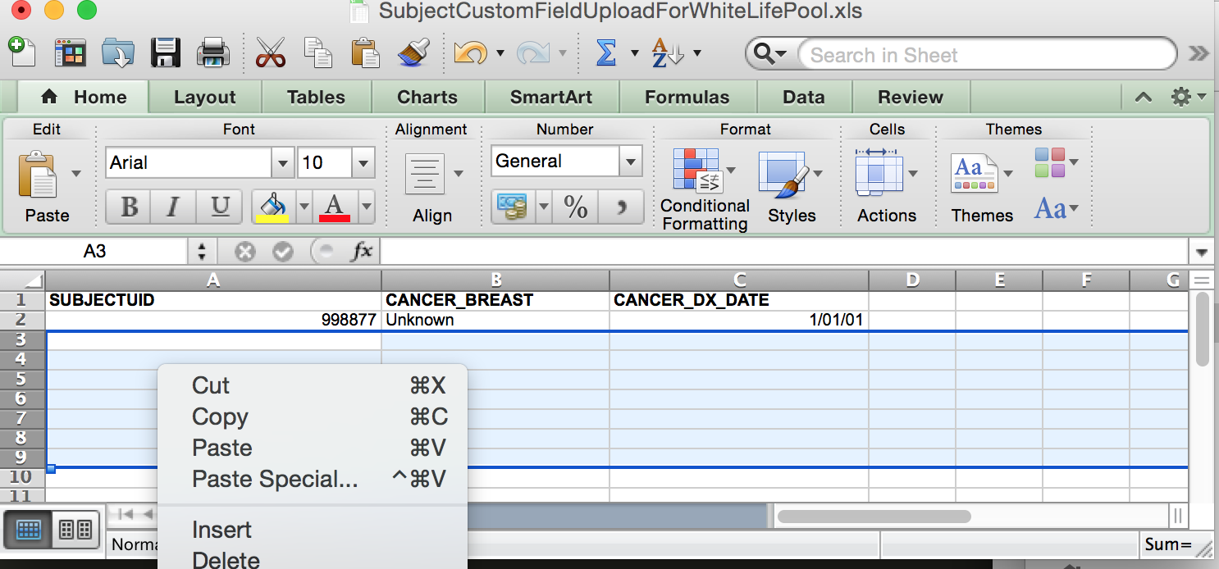

Step 5: Now save as CSV file.

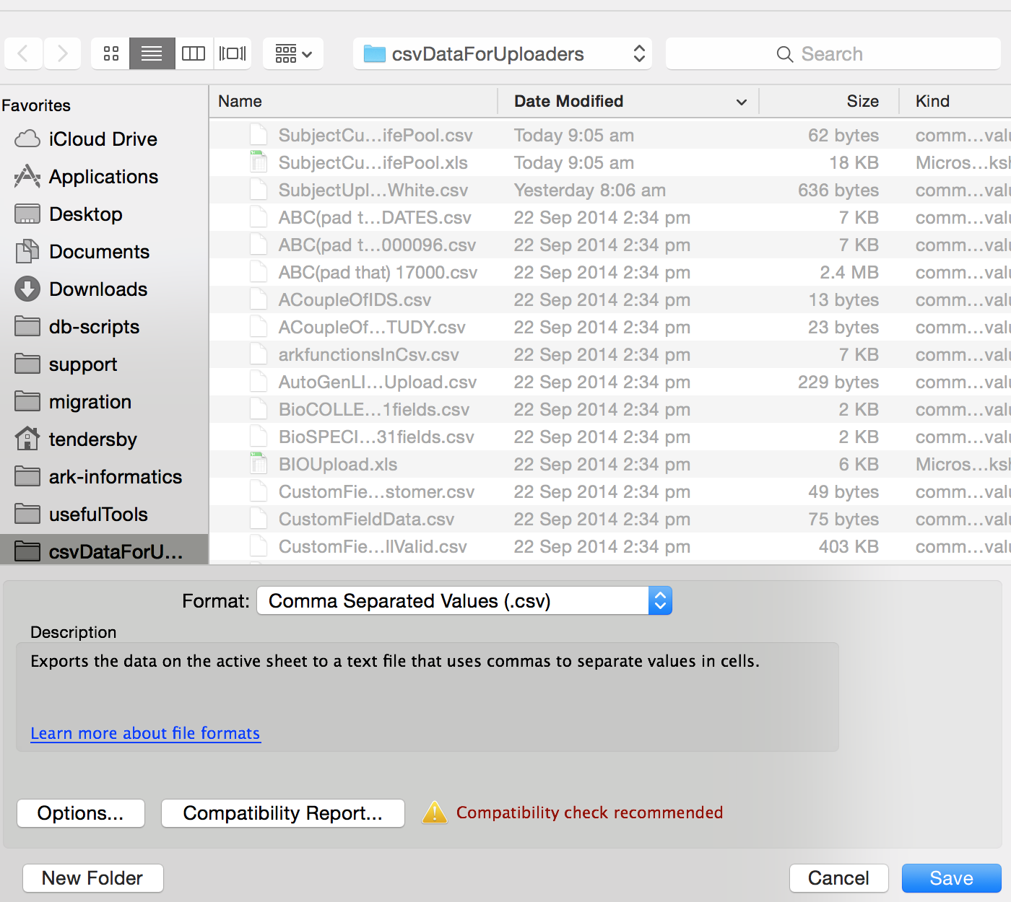

Step 6: Check your data in a plane text editor (eg; Notepad, sublime edit, vi, vim, TextEdit). It should now have no extra commas and no extra lines.

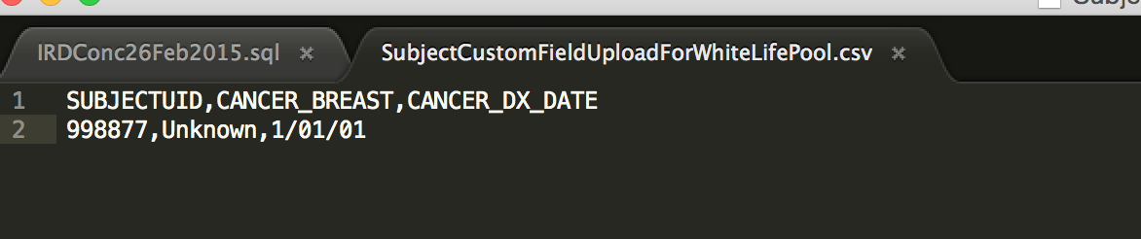

So now our upload data is as expected, we can try again.

We click cancel at the bottom of The Ark page and start the upload again.

So now that I have corrected the headers on my file, I repeat step one and see if there is any more mistakes

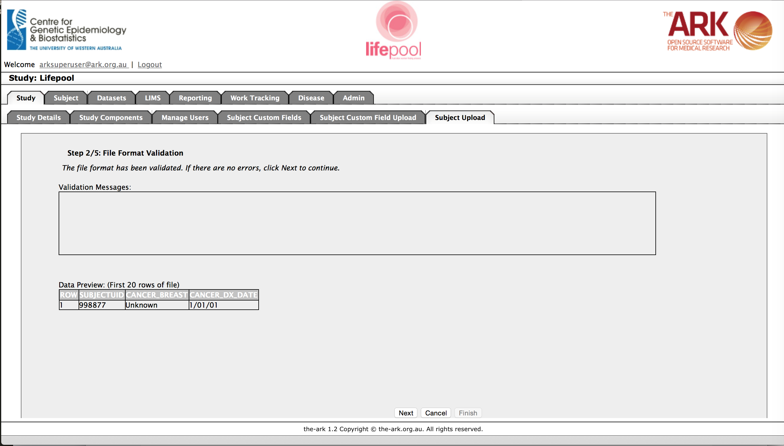

I see no validation messages at step 2, so I can assume everything is ok and click next at the bottom of the page (the next step will validate all of your **data** Vs what is expected, so can take some time on very large files. Please be patient and don’t click back, as it is busy doing work and will let you know when it is complete).

We are now at step 3. This step shows if anything went wrong in step 2. The validation messages say Unknown is not a valid encrypted value, as it is expecting the key value, ie; 9. So I have to fix the data and try again.

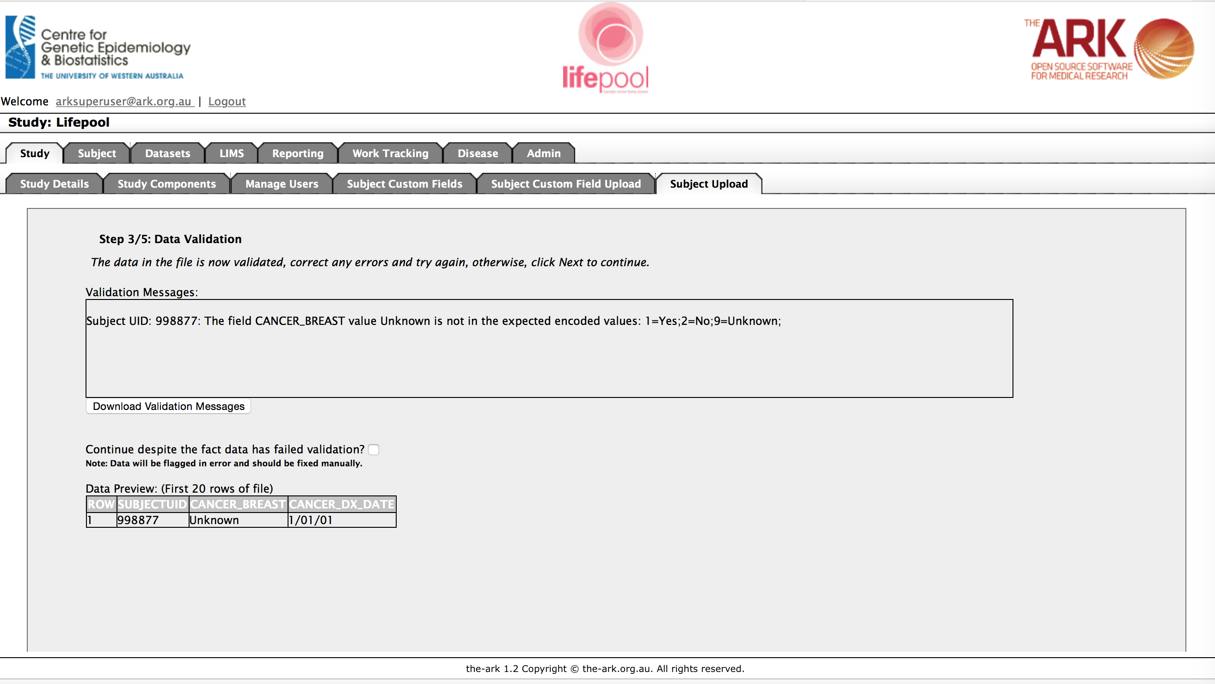

Click cancel and go and fix your data, and then repeat steps one and two again.

If we have corrected all of our data error we will now see an empty box for the validation messages.

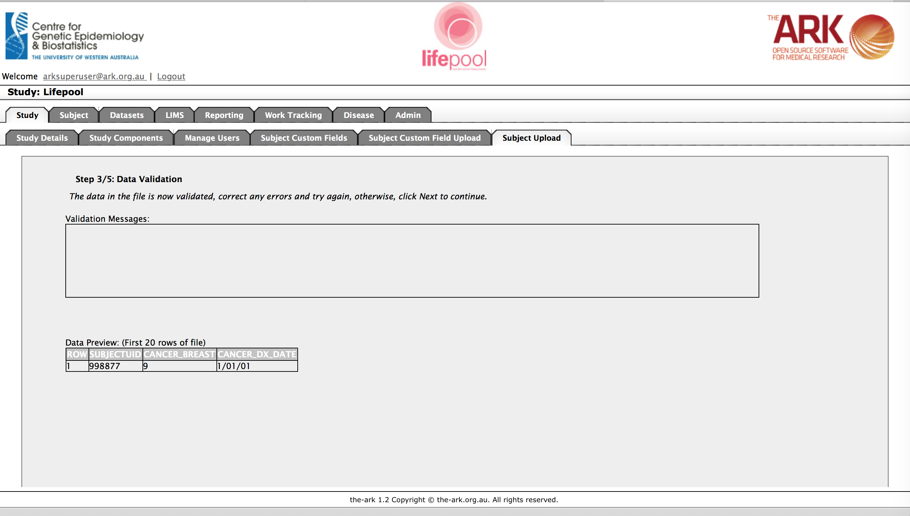

You can therefore click next if you are happy with the data you see.

You have now confirmed you are accepting the data, click next one more time and a BATCH process will begin.

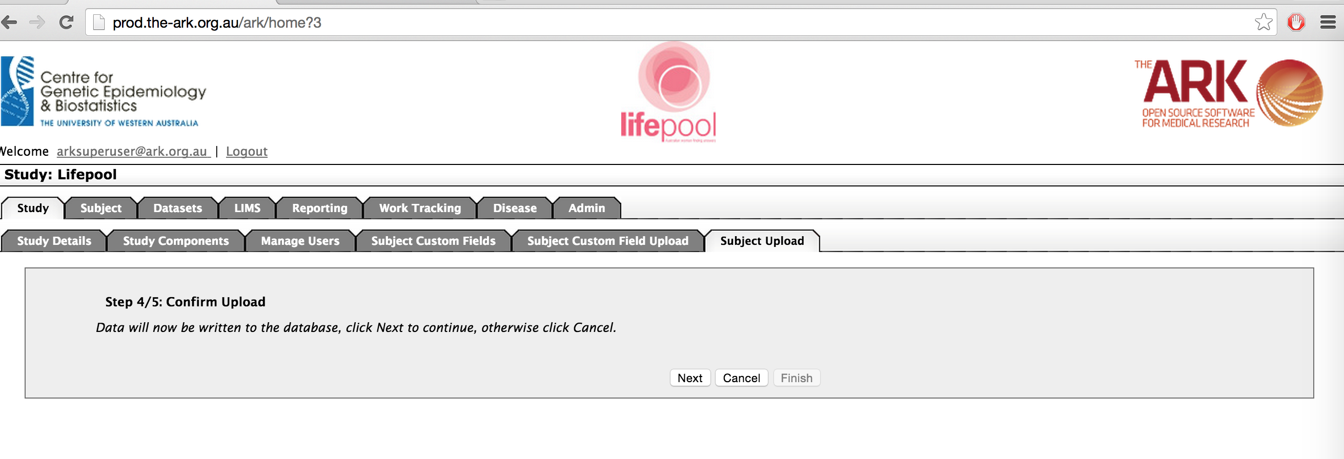

You now have completed the final step and can click finish whenever you want…

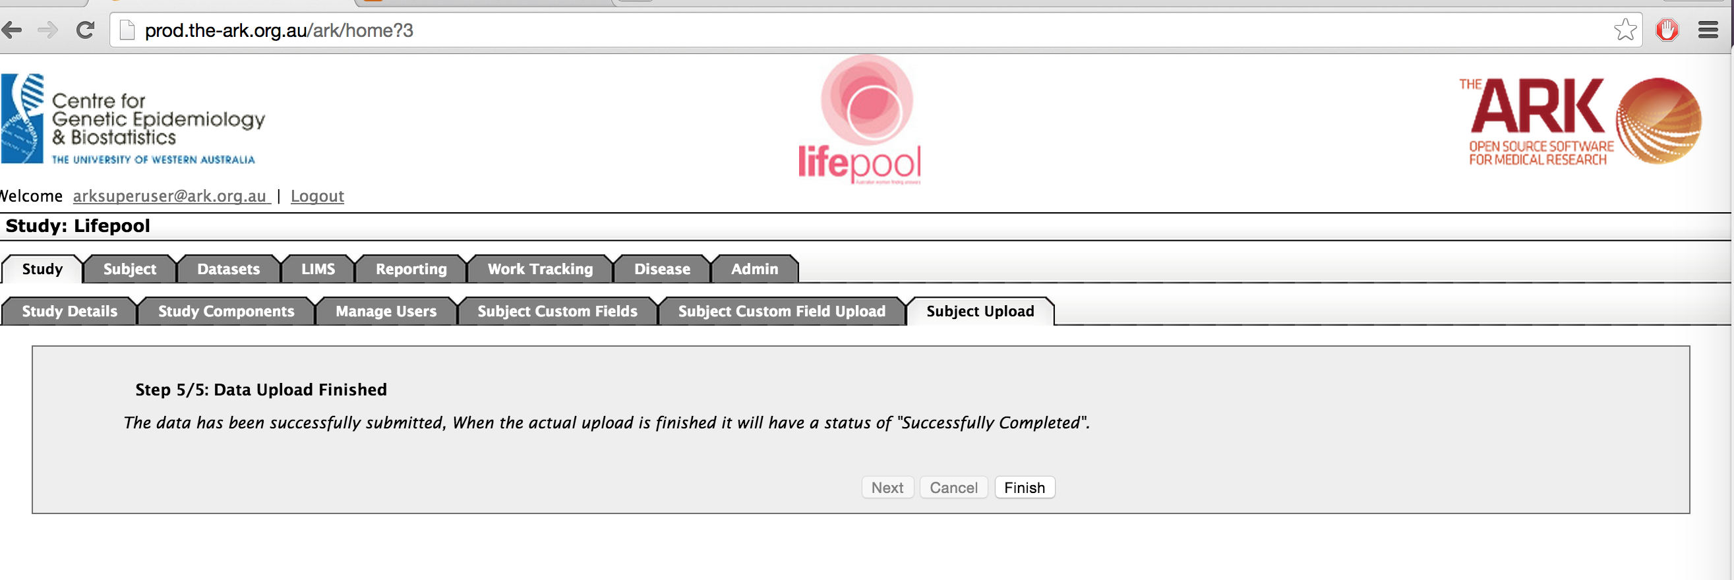

BUT must know that the data has been submitted BUT it has not been completed until the result list page says that your upload is in a “Successfully Completed” status.

This is what a successful upload will look like on the result list section. You can also see what you two previous unsuccessful attempts looked like (the first time we failed validation of the file (headers or file type/format), the second time we failed validation of the data.

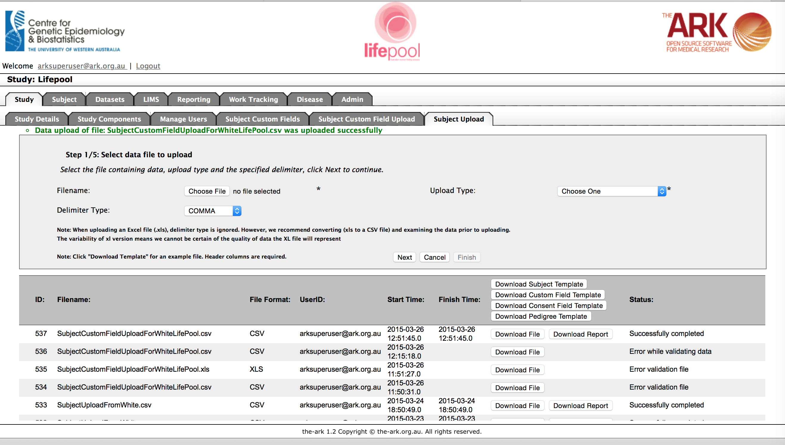

As you can see, in the results list for our successful upload, we have the options of Download File (this will down the original file you used) or Download Report which will give you a summary of what was uploaded, and any assumptions (or less serious errors) that were made upon successful rows. See an example below;

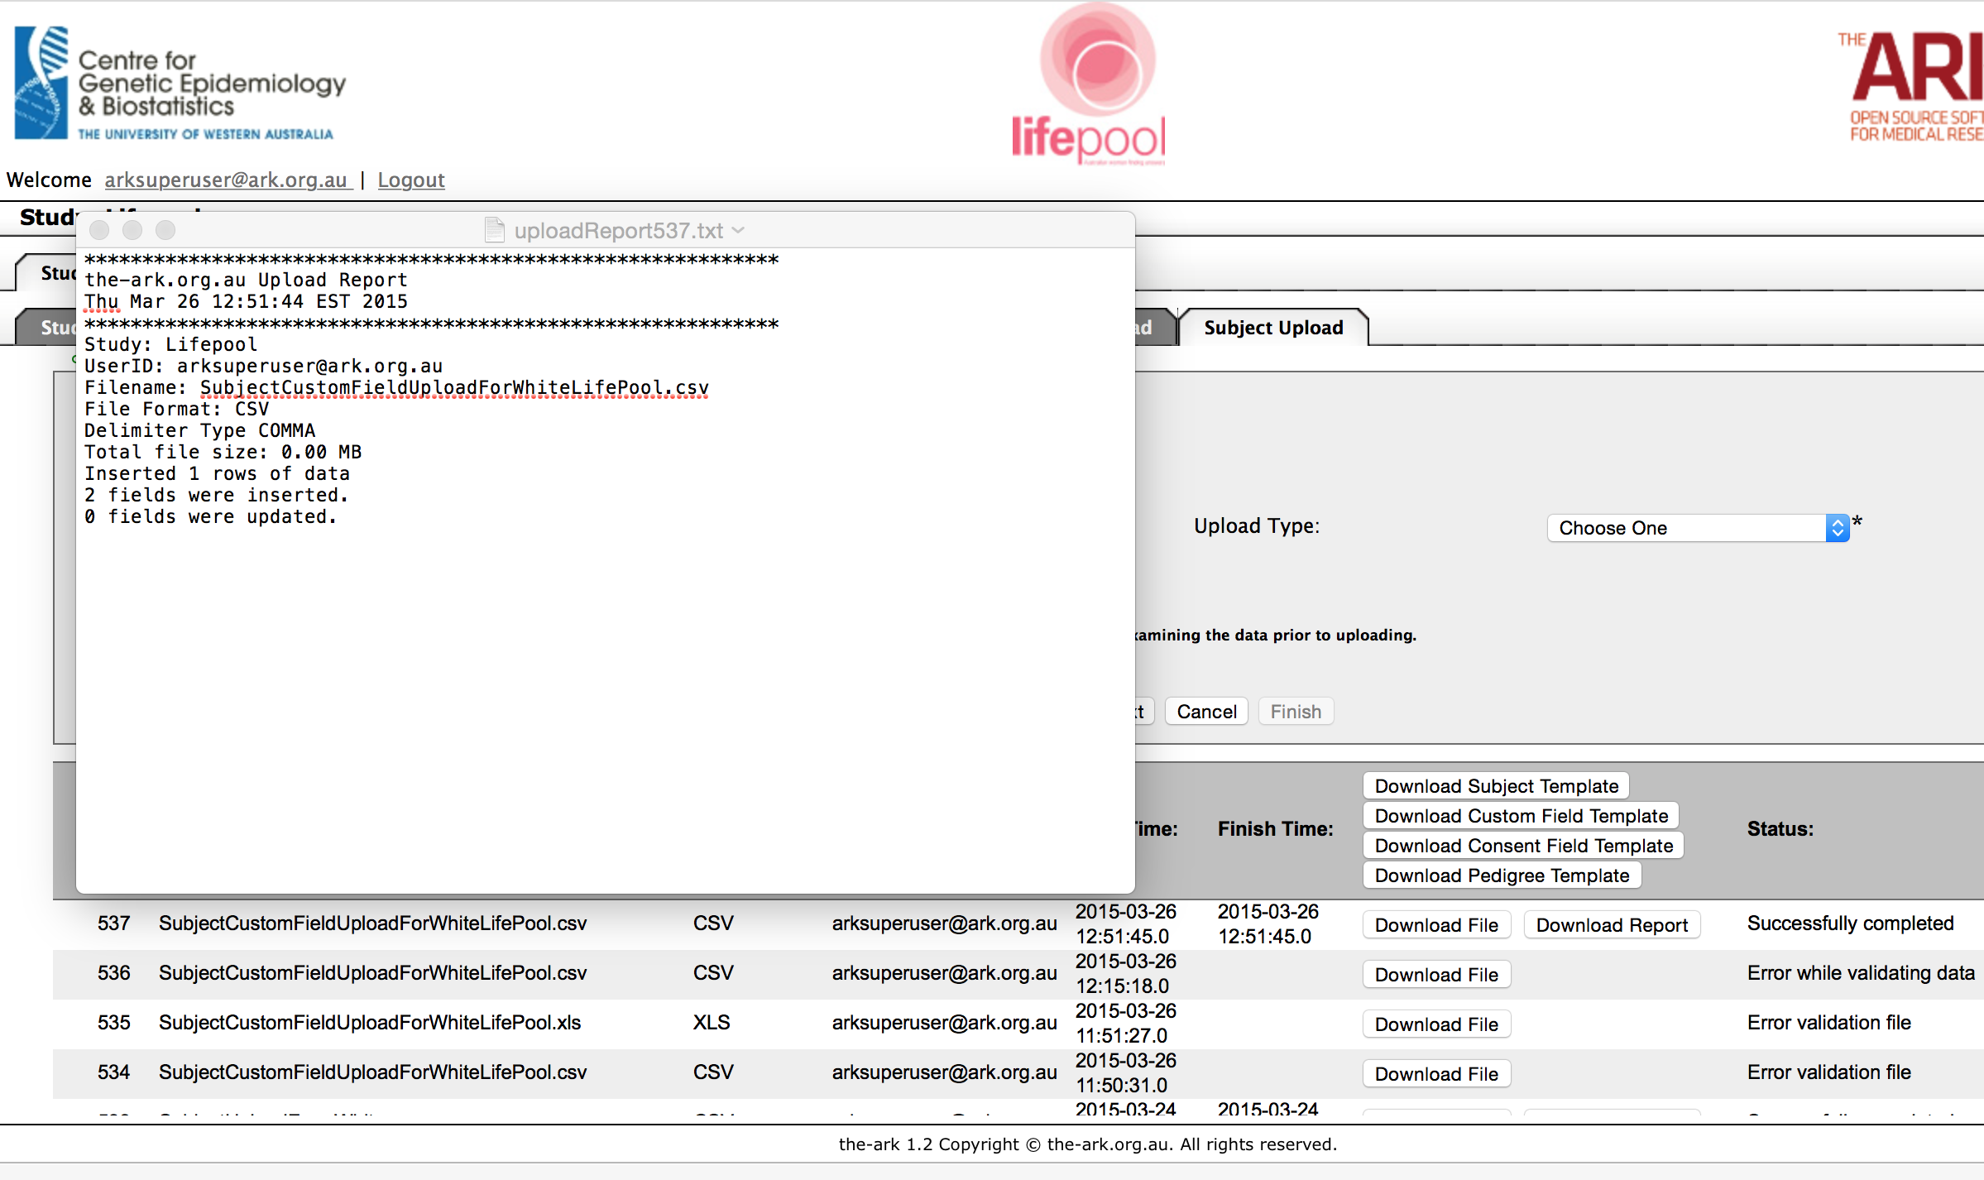

As always, we recommend you test what you just did to ensure the results were as you expected.

To do this, we click on the Subject Module Tab near the top of the page.

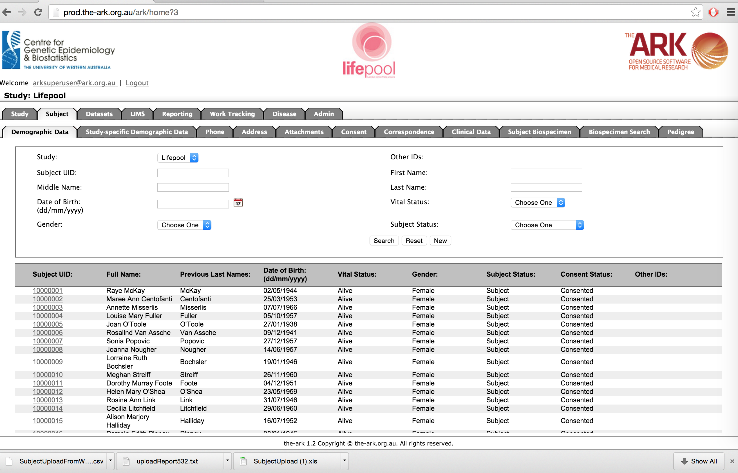

We can use a search term to find out subjects we wish to test;

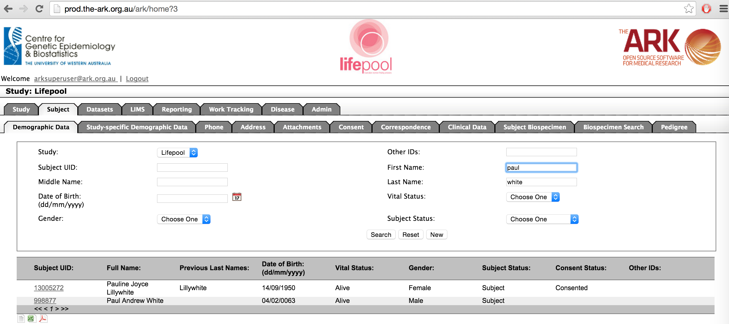

As you can see we found the name we just uploaded (Paul White). Click on his SubjectUID to test put this subject in Context.

Your next step is to click Study-specific Demographic Data to see if the data was uploaded as expected. Hopefully all the data you expected is there. As we can see, our two fields are there as we expected.

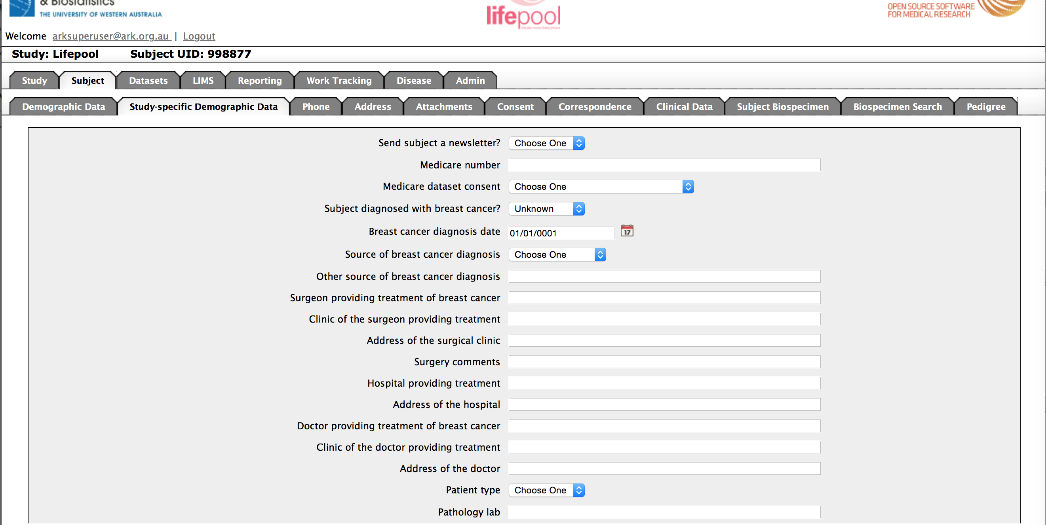

One thing to note is that we entered the data in DD/MM/YY format. The Ark took this literally as 01/01/0001, if we wanted to enter that as 01/01/2001 we need to enter it exactly that way “01/01/2001”. We will do that in our next guide “The Ark Documentation – SubjectCustomFieldUploader – Updating”